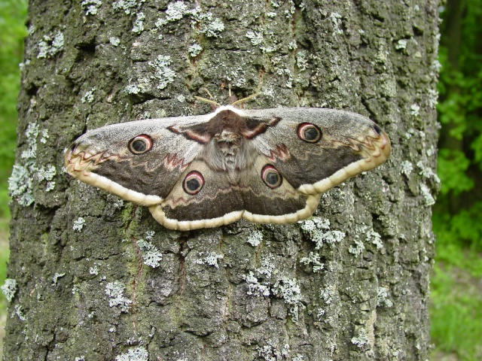
Latin: Saturnia pyri
English: Large emperor
Czech: martináč hrušňový

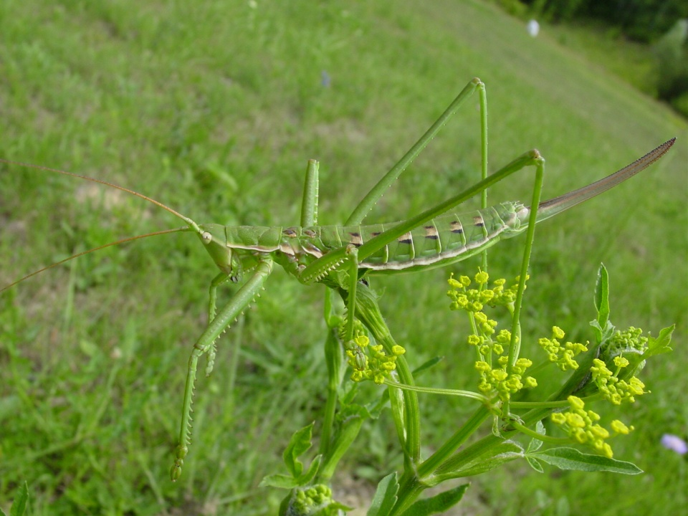
Latin: Saga pedo
English: Steppe cracker
Czech: kobylka sága
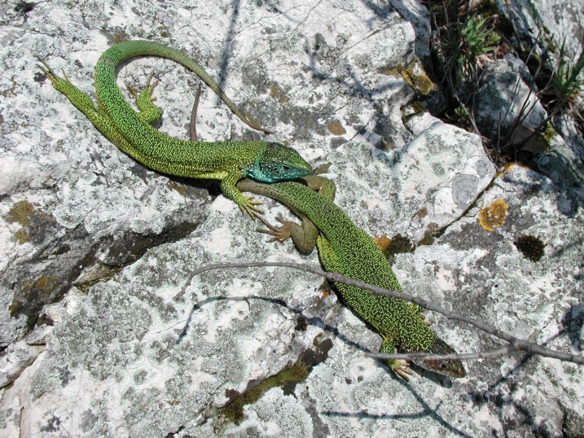
Latin: Lacerta viridis
English: Green lizard
Czech: ještěrka zelená

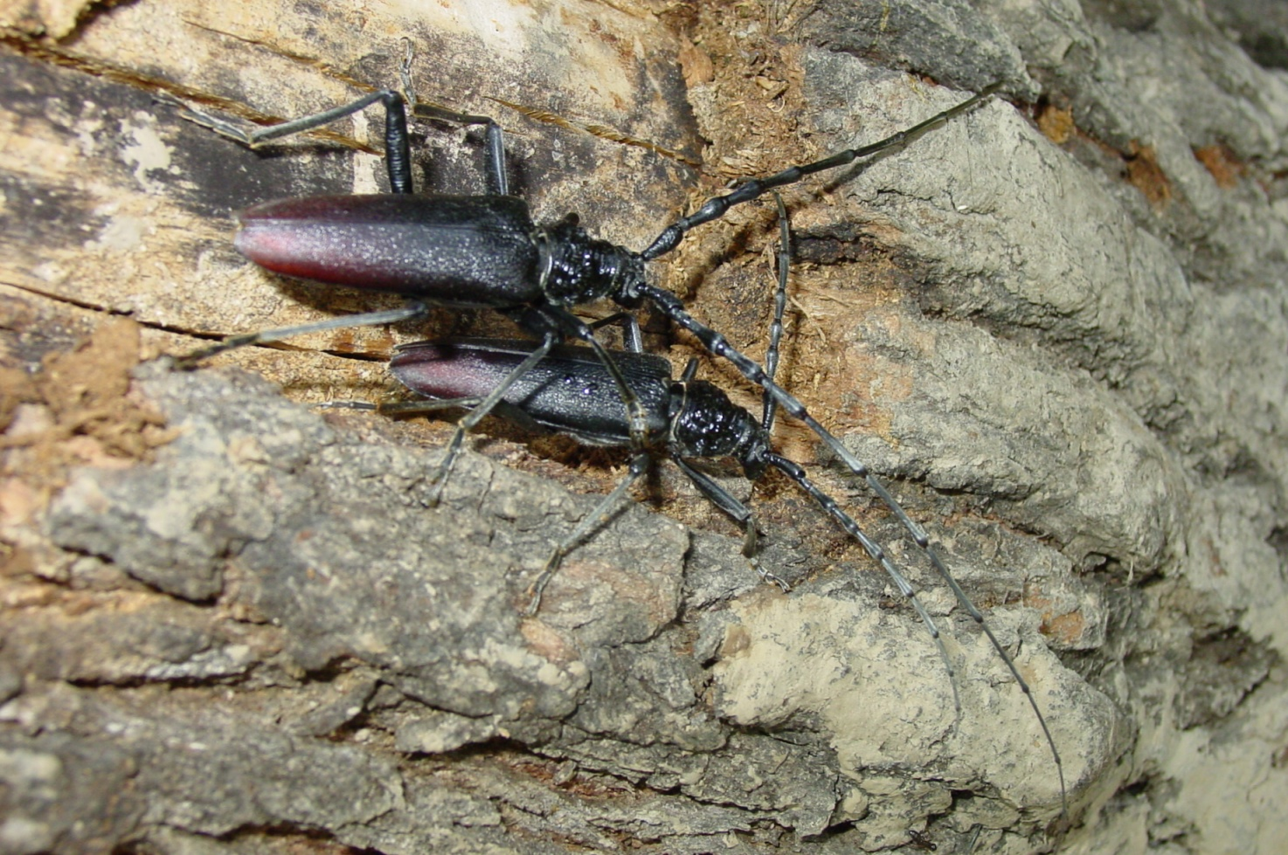
Latin: Cerambyx cerdo
English: Great capricorn beetle
Czech: tesařík obrovský

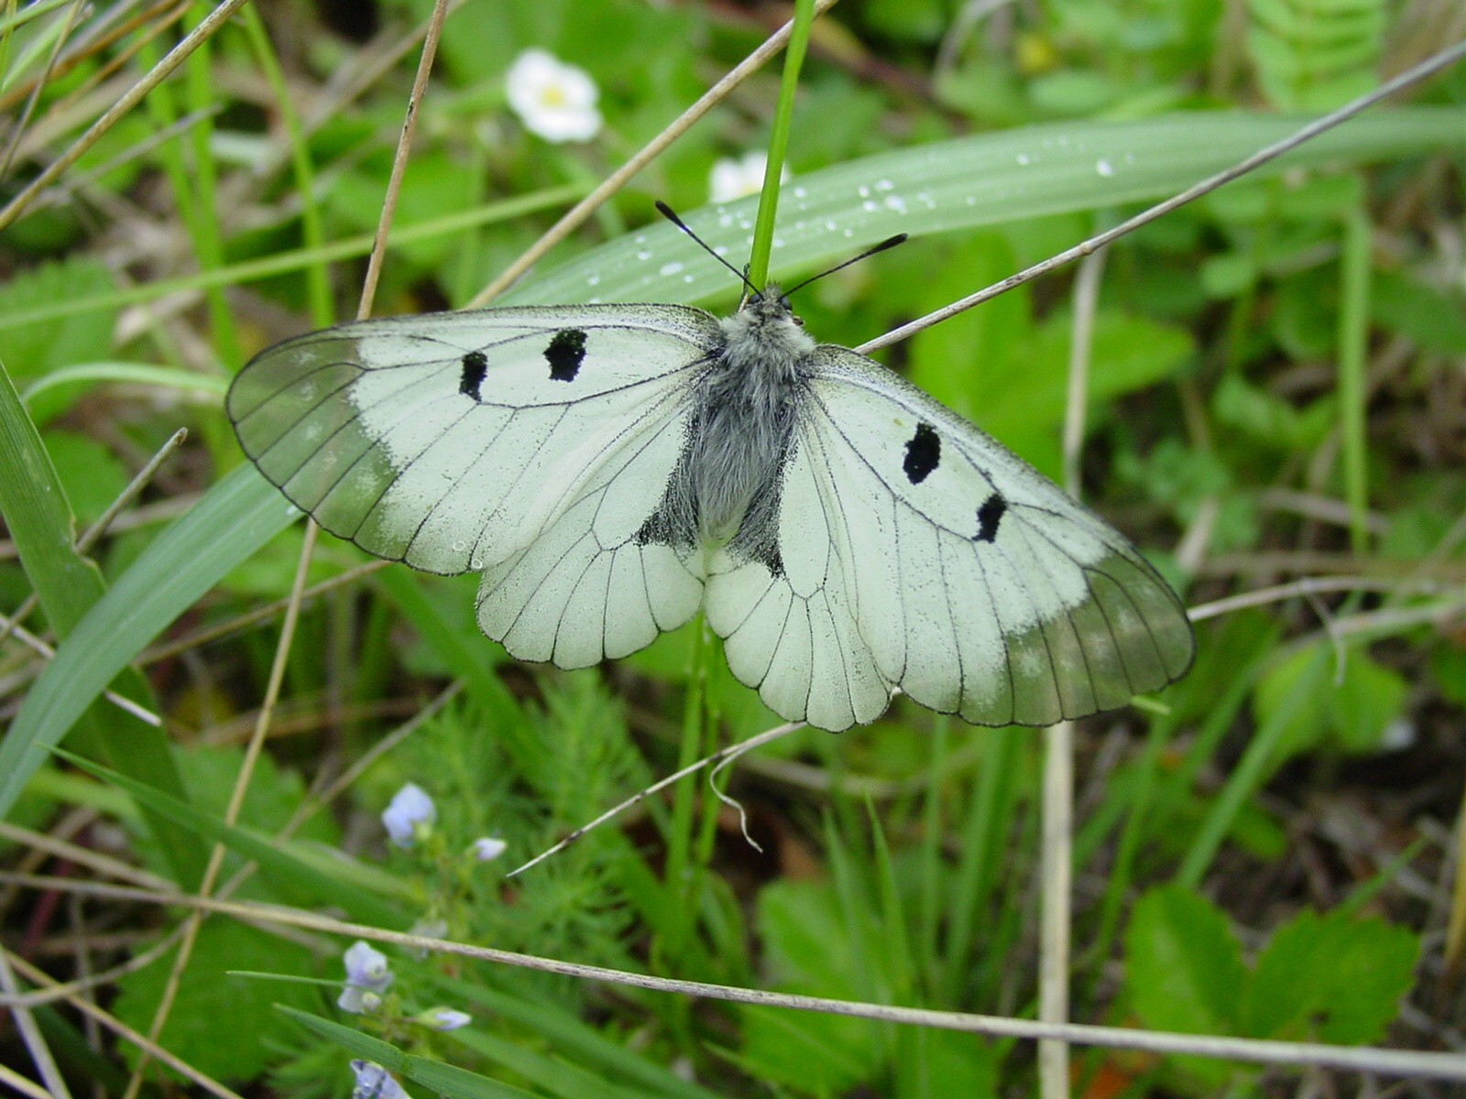
Latin: Parnassius mnemosyne
English: Black apollo
Czech: jasoň dymnivkový

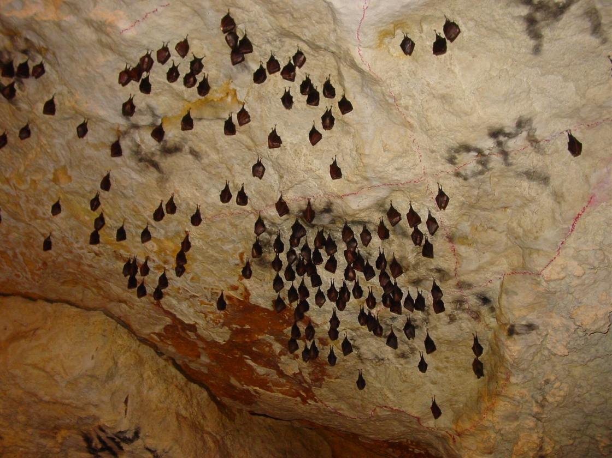
Latin: Rhinolophus hipposideros
English: Lesser horse-shoe bat
Czech: vrápenc malý

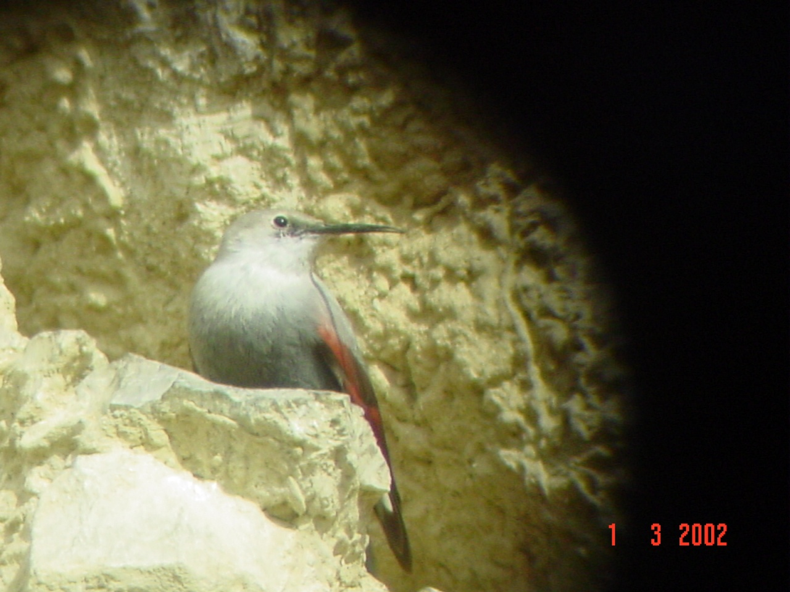
Latin: Tichodroma muraria
English: Wallcreeper
Czech: zedníček skalní

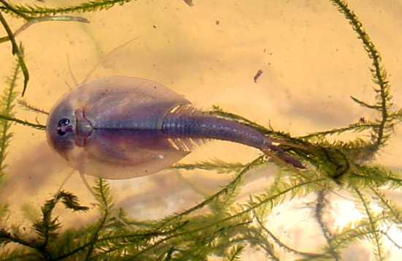

Latin: Lepidurus apus
English: Tadpole shrimp
Czech: listonoh jarní

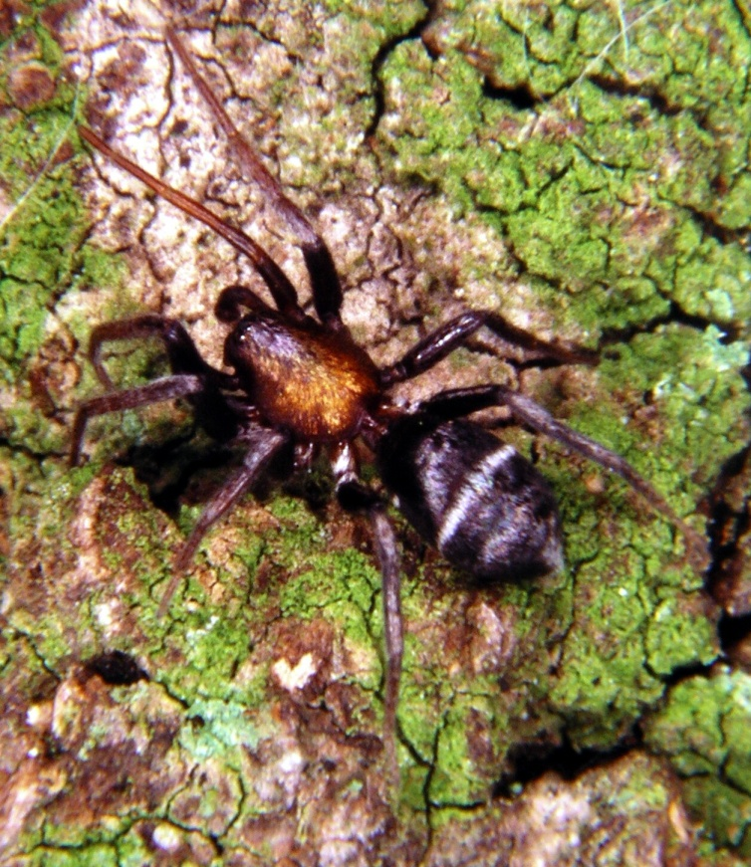
Latin: Micaria sociabilis
English: --
Czech: mikarie pospolitá

