Novomlýnské lakes vs. Nature

There were a lot of disputes and discussions about three lakes – Mušovská, Věstonická and Novomlánská. They refered to the problems with this huge building – the impact on nature, using large water surface. It turned out, they don’t do that what should do. Large areas had to be overflowed, the residents of Mušov had to be evacuated. The only remaining thing is the church on a small island in the middle of the water surface. I admit, the water surface and the profile of Palava hills are indescribable.
The main negative was the fierce modification of the countryside most decidedly. The original flood-plain forest disappeared in a moment. There are thousands of holiday makers today. Fishing boats are frightening nesting birds.
Everything started in the fifties. The reason was for example channelized flows. The floods were coming more often. The project for subjugation of nature began in 1965. Maybe is too late for renewal of flood-plain forest now.

The characterization of flood-plain forest

Flood-plain is one of the most multifarious ecosystems. It’s rich in flowers and animals. The most important is the existence of a river or a lot of underground water. It may be turned into a jungle after summer rains. Meanders are important too.
All flood-plain forests aren’t the same. It depends on the quantity water, the kinds of soil and the frequency of floods.

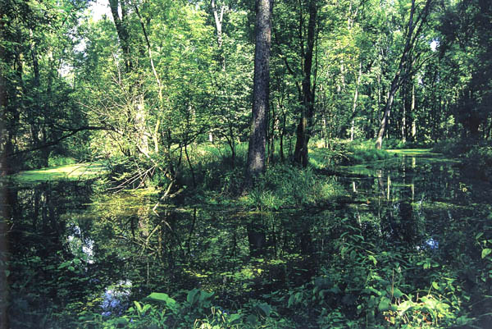

Flora

There are willows and adlers more closely the river. Farther are aspens. This part of the forest is called soft flood-plain (trees have a soft lumber). In hard flood-plain are growing oaks and ashes. We can find bird cherry, money suckle, snowball tree or elders in bush-area.

- elms, water lilies, pound lilies, cattail flags, wolf’s-milk, snowflakes, scilla, angelica forget-me-not, iris, creeping crowfoots, touch-me-not, nettles

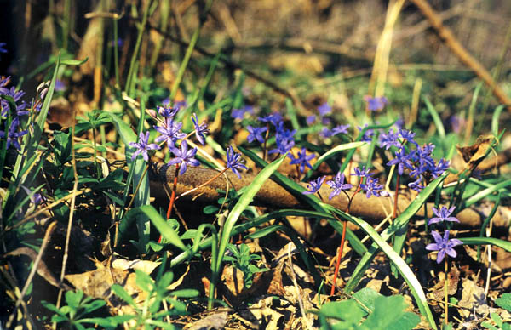

Fauna

There are a lot of bugs, amphibians and birds. For example storks, reed warblers.

- terns bald coots, whistling swans, blubills, herons, black kites, sea snipes, godwit
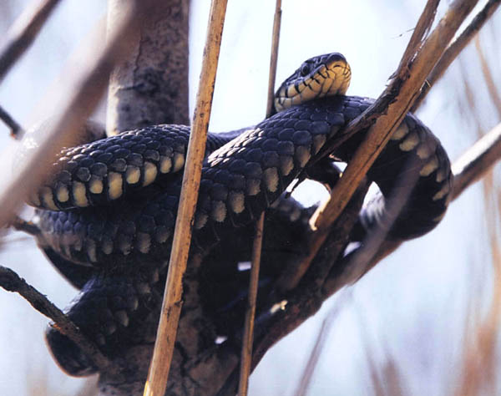
- ring snake, eft, muskrat, toad

