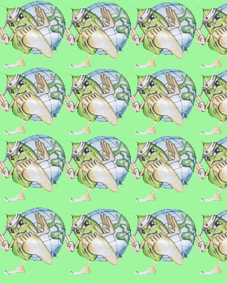
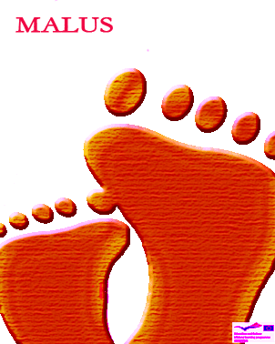

You have left the
tap opened
You left the
tap opened
You take
1 foot

You take
1 foot

You have washed
vegetables
under
running water

You take
2 feet

You have
washed
your car with running
water and chemical
detergent

You take
3 feet

You haven't had
a shower instead of
bath

You take a
foot from
another
player

All your
taps are without flow
reducers

You take 2
feet from another
player

You have left the light on while
you aren't at home

You take 2
other malus
cards

You have turned on light
on morning with
sunlight

You take a
foot from each
player

You have useed softening

You throw
your next
bonus card

You have been using your garden games equipment without taking environment
I into
consideration

You don’t
throw the
dice this turn

You have
Installed waterproof garden
paving

You take
1 foot

You have trashed plastic
together with paper

You take
2 feet

You haven’t
sorted your
rubbish

You take
3 feet

