
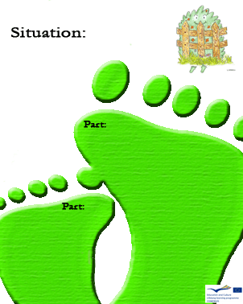
1
C
Is it correct to turn on the lights on a sunny morning?

A - B

Is it safe to play with garden games equipment without taking environment into consideration?

a)Yes, it is always safe

b)No, it is never safe

c)No, but it is good
for the environment

it safe to play with damaged games in the park?
1
A

A - B

Is putting a lamp near another one a good way to get more lighting?

a)Yes, so you can get better
lighting

b)No, it is a waste of
energy

c)Yes, it is a good thing
to improve the appearance
of the garden

Is it safe to play with damaged games in the park?

1
A - B

Is a hidden lamp a waste of energy?

- No, it is not important

- Yes, a hidden lamp is useless

- No, it could be a good thing

C
Is using low power lamps a good way to save energy?
1
D
If we save energy do we also save money?
3
D
Is it correct to recycle?

C

Is it useful to turn on the garden light at the daytime when it is bright?
a)Yes, it is always useful

b) No, it is a waste of
energy

c)It is useful only on
Saturdays

