
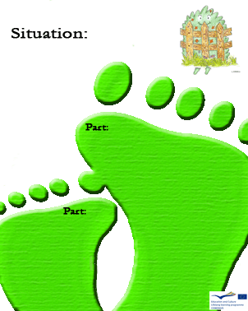
3
B

For soil fertility it is better to use:

- Chemical fertilizers;

- Natural fertilizers;

- Both.

D
Is it correct to recycle?

3

A

Which object takes more time to disintegrate?

- A telephone cards;

- chewing-gum;

- Plastic.
.

D

Can plastic be recycled?

3
C

Which object takes less time to disintegrate on its own?

- A match;

- A cigarette butt;

c) A tissue
C
Do glass bottles take 1000 years to disintegrate?

3
C

Which of these is not an organic waste?

- Glass;

- Grass cutting

- Leftovers

C
Can wood be used to prepare compost?

3
C

How long do glass bottles take to disintegrate?

- 500 years;

- 1000 years;

- Unknown.

C
Do newspapers take ten months to disintegrate?

