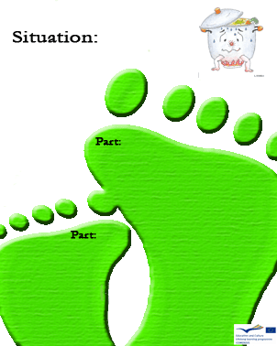

1
C

Which is the most suitable oven?

a) The conventional one

b) The mini electric oven (Remoska)

c) The microwave oven

1

C

Is the use of a lid necessary during cooking?

B- D

What´s the best way for washing up the dishes?

a) In a sink with water

b) Under running water

c) In a dishwasher

D

Is the use of
air-conditioning important?

1
Is the use of a fan important?
1

C

How can you save the largest amount of energy?
a) By cooking in a pot with a lid

b) By using a fan when cooking
c) By cooking without a lid or a fan

C

D

Which is the best place for a fridge?

a) Cold place

b) Hot place
c) Garden☺ (Kitchen)

B
Is it important to measure the water when you put an electric kettle on to
make a cup of tea?

1
Can we put a saucepan with hot soup into the fridge?

A-B

Which is the most economical way to boil water for tea?

a) In an electric kettle

b) Using a gas cooker

c) Using an electric cooker oven

D

