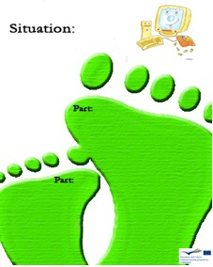

1

B

How can you save the largest amount of energy when working with your PC?
a) By switching your PC off
b) BY using „stand by“ mode
c) By letting it in process (working)

B

Is printing on both sides of a sheet of paper economical?

1

C

2) You kill trees when…
a) You waste paper
b) You save paper
c) You use a new sheet of paper to do your homework

D

Is the use of air-conditioning important?

1

C

Who is the biggest consumer of new paper?
a) China
b) The USA
c) Kenya

D

Is it necessary to print every e-mail we receive?

1

C

What percentage of today’s world wood production is used to make paper?
a) 90%
b) 45%
c) 17%

B

Is it important to switch the computer off when you leave the office?

1

C

Which is the most economical source of light?
a) Light bulb
b) Fluorescent light bulb
c) Candle

Should used paper be thrown into a trash bin?

D

