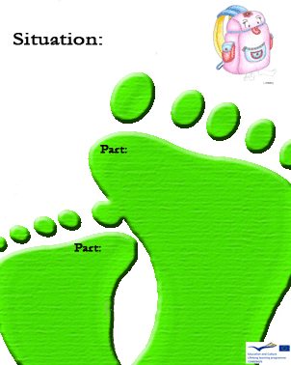
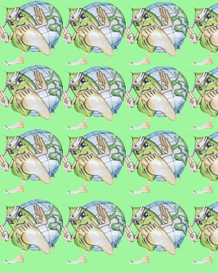
1

C
Glass melts at
- 1300
- 1400
- 1500

C

Is methane a natural gas?

1

C
To make a becker you need silicon, calcium carbonate and
- Soda
- Quartz
- Magnesium

B

Can’t pirex glass be recycled?

1

C
Methane can be extracted from:
- manure
- igneous rocks
- moss

B

Can plastic be recycled?

C
1

C

Methane is a..
- natural
- artificial
- biologic ---- gas

C

Can methane be extracted from moss? 3

1
Can toxic substances be disposed of?
B
Is it impossible to recycle
- plastic
- wood
- ceramic glass

C

