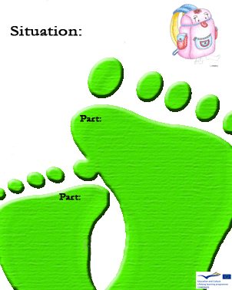
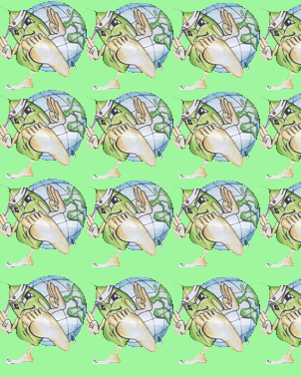
What does chewing gum cause?
  - A weight loss
  - A toothache
  - A headache

C
2
Is methane a natural gas?

C

2

C
To produce 1 ton of vergin cellulose you need? 3
  - 15 trees
  - 30 trees
  - 10 trees

2

C

To produce 1 ton of recycled paper you need? 3
  - 1800 litres of water
  - 200 litres of water
  - 1200 litres of water

C
Where does latex come from?
  - From the milky sap of the rubber tree
  - From its leaves
  - From its roots

which is the correct behaviour to keep in a lab to avoid bacterial contamination?
  - Respect the rules
  - Walk around the lab
  - Cause trouble

C

