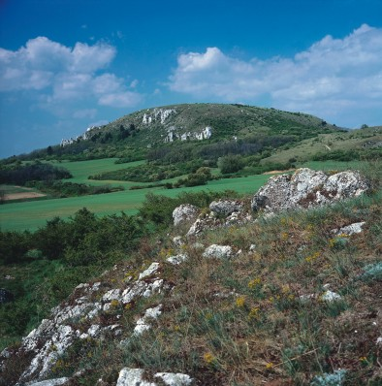
Děvín

Děvín is by his altitude 554 m.a.s., the highest laid spot of Palava, and her northeast creek too (between Pavlov and Dolní Věstonice). The whole area of Palava was in the past several times transmuted, you can find here shapes from the Mesozoic era( older sediments and younger, so called Štramberk calcites) and Cainozoic , which formed Palava, like we how her now. Děvín however, has a strategic function too. He created a bussiness crossing, and there was made the original royal castle Dewiczky( he became a part of the lichtenštejn state in the year 1334, and he lost his function).

From the natural biotope dominates the so called karstic forest steppe, which is made from coloured mosaic lapidary, dry grass, border union, xerophilic bushes and thermophilic oak woods, which originated from a part of the influence of pasture.Palava, which is Děvín a part of, is generically the richest location in Czech republic.

The creeks of the slopes of Děvín hide a ton of kinds of flora, which are in CR rare and are affected only here (for example sandwort large-flowered).

The section raising (especially the raising of goats bezoar,fallow-deers and mouflons, which were planted out with the help of the zoology workers, in the year 1953) was in the year 1996 completely stopped by reason of weakening of the naturality of the scenery.

For many species of animals constitutes Děvín the only location of appearence, thanks to direct allegiance some of the sorts on certain flora assistants.(for example hymenopterous larva of sawfly lives only on the sword flag low, the caterpillar of yellow butterfly evolve on locoweed austria). On northwest orientated slopes appear even piedmont till mountain species (for example some sorts of moths).

Biotopes with typical flora assistants:

- movable debris of carbon rocks –narrow-leaved hamp- nette
-lapidary growth – garlic yellow, sword flag low , in the last time there are problems with air-raid wood species
- rammer lawn - pěchava calciphile and the only endemic species of Palava dianthus Lumnitzer palavy
- subpanon steppe lawns – adonis springy, problems with footworm (but on these locations is enforced the appearence of fescues)
- leafy dry lawns – cornflower, spinifex
-panons oak-hornbeams – oak wintry, cornel common, corydalis
-debris woods – lime heart-shaped, nettle dioecious
-thermophilic oak woods – oak flakey, cornel common, adonis springy,problems with devastation lower plants because of animals.

